https://www.hpe.com/ru/ru/contact-hpe.html
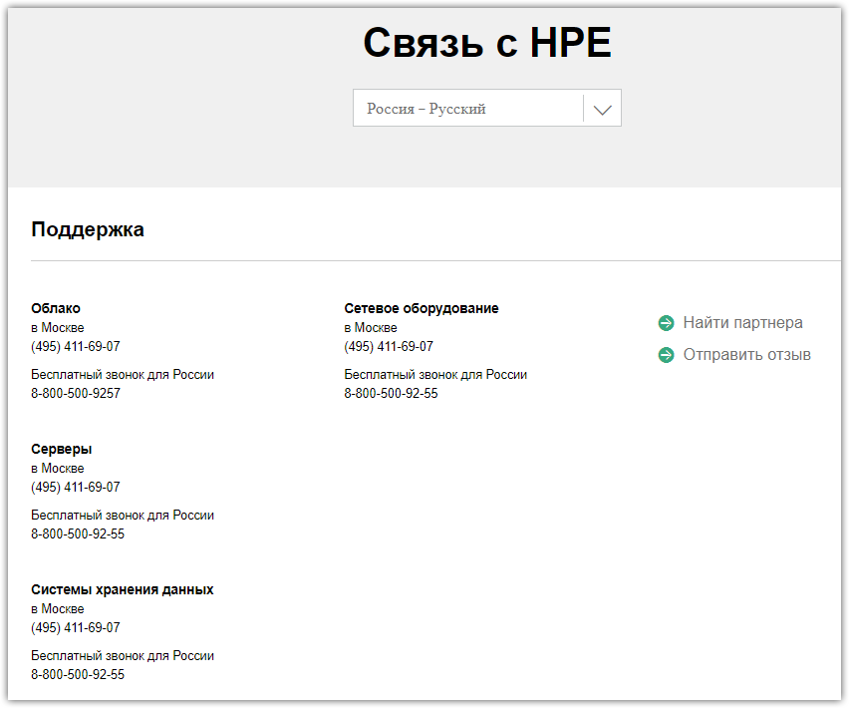

https://www.hpe.com/us/en/contact-hpe.html
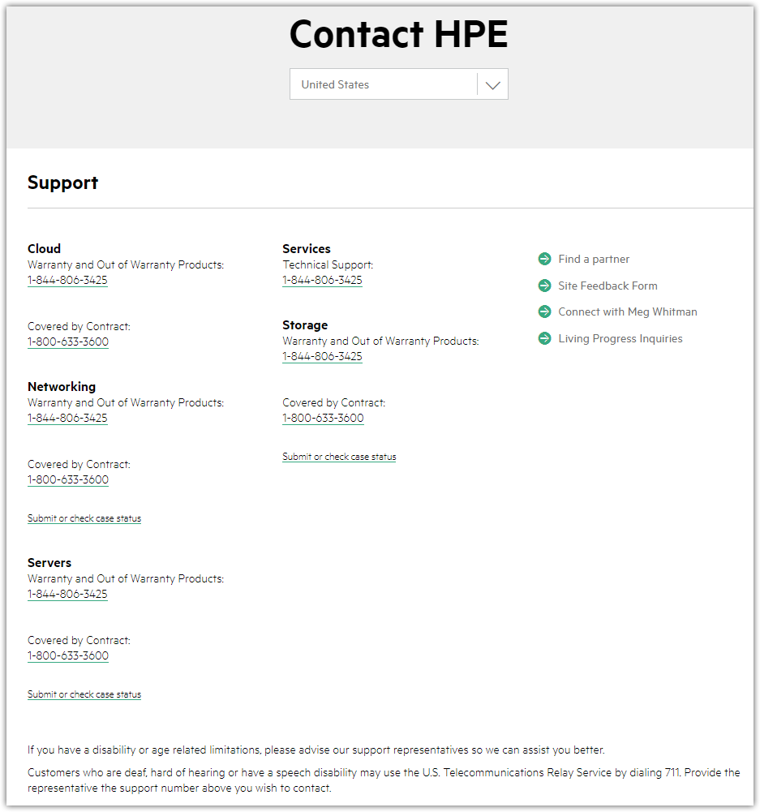

# To open a case about some event on server’s hardware, it’s need to go to follow URL and enter appropriate account information.

hpe.com

# There are, at least, two way to open web-page, where we can get support.

# One of way is find server with appropriate serial number.
# And then do follow.
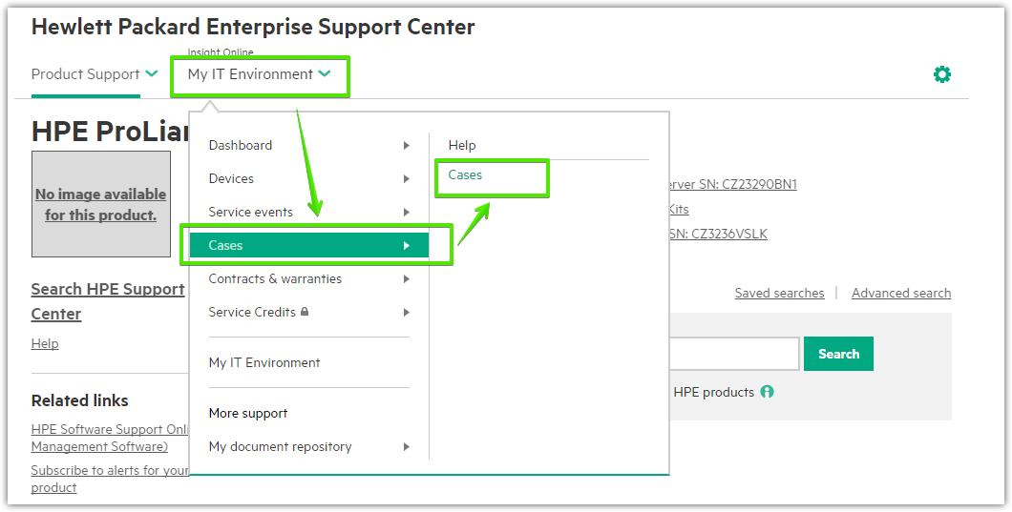

# The second way is open follow menu point.
